Aloaha legacy Single Sign-On
RDP Launcher
Aloaha legacy Single Sign-On improves security and simplifies the user experience by automating access to all legacy applications through a single authentication. This enables implementation of stronger security practices without burdening users with remembering multiple username and password combinations.
The newest version of this document is always available as:
PDF: http://www.aloaha.com/handbuecher/l_sso.pdf
DOCX: http://www.aloaha.com/handbuecher/l_sso.docx

Contents
Introduction 2
Remote Desktop Launcher 2
Create and Edit 2
Create 2
RDP Autostart 3
Call pre-configured RDP Session 3
Definition of RDP Folder 3
Legacy Application Single Sign-ON 4
Aloaha SSO Template and Data Editor 4
Node Deletion 4
Buttons 4
Template Creator 4
Use data files 5
Save as active 5
Use template files 5
Save as template 5
Save 5
Aloaha Template Creator 5
Settings 5
Registry 5
SysTray 5

Introduction
Aloaha Single Sign-On exists as a stand-alone package and is also included in Aloaha Smartlogin. For full functionality the user needs to install Aloaha Smartlogin.
Smartlogin evaluation download: http://www.aloaha.com/download/smartlogin.zip
Please contact info@aloaha.com for an evaluation key.
The portable stand-alone version can be loaded from:
http://www.aloaha.com/download/rdplauncher.zip

Once Aloaha SSO / RDP Launcher is started you can see it in the system tray area as shown below:
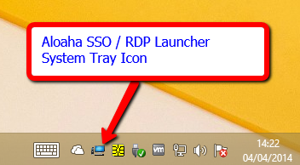
Picture 1: RDPLauncher.exe

Remote Desktop Launcher
One of the main tasks of the Aloaha System Tray is to give the user a fast way to launch pre-configured RDP Sessions without having to type in always the username and/or password.

Create and Edit

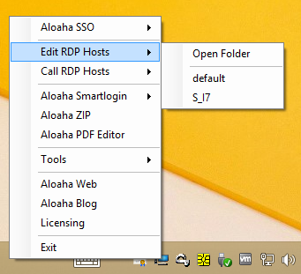
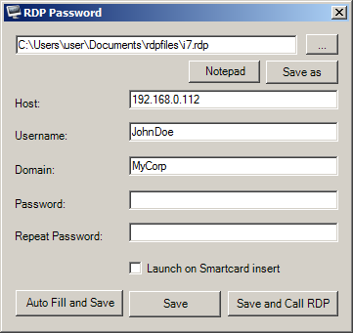

Create
To create a new session please go on “Edit RDP Hosts” and choose “default” or one of your previously created templates. You can then click “Save as” to create a new template or edit the chosen template itself.
With a click on “Notepad” you can manually edit and fine tune some properties in your template.
Please fill in Host, Username and optional the Domain. If you leave Username empty Aloaha will try to retrieve it from your Smart Card, PKCS #11 Token or USB Stick. The same is valid for the Password field.
As soon you leave it empty Aloaha will use your Smart Card, PKCS #11 Token or USB Stick to retrieve it.
Please note that the retrieval of Username/Password from your Smart Card or USB Stick will ONLY work if you assigned your user with one of the tools in “Aloaha Smartlogin”.

RDP Autostart
If you activate the check box “Launch on Smartcard insert” Aloaha will launch this template every time it detects the insertion of a smart card. As soon you remove the card the session will be disconnected fully automatic!
To know which template to launch on the insertion of the card Aloaha looks first in:
HKCU\SOFTWARE\ Aloaha\CSP\RDPAutoLaunchFile
and then in
HKLM\SOFTWARE\<Wow6432Node>\Aloaha\CSP\RDPAutoLaunchFile

Call pre-configured RDP Session

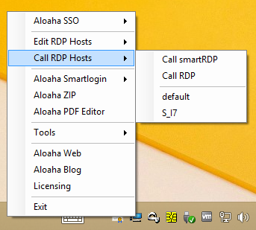
Just click on the template to be called. Aloaha will launch the configured RDP template.
Passwords are retrieved fully automatic from your smart card or USB Stick. Obviously that works ONLY if you assigned your smart card to the user with “Aloaha Smartlogin” -> “Card Credentials”
or your USB Stick with
“Aloaha Smartlogin” -> “USB Credentials”
of if you saved your credentials on your PKCS #11 Token with
“Aloaha Smartlogin” -> “PKCS #11 Credentials”
Detailed functionality is explained in the Smartlogin manual.

Definition of RDP Folder
To fill the list Aloaha reads the RDP file from the user folder. To detect the user folder Aloaha first reads HKCU\Software\Aloaha\CSP\MasterRDPFolder. In case that is empty Aloaha reads HKLM\SOFTWARE\<Wow6432Node>\Aloaha\CSP\MasterRDPFolder.
ONLY if even this is empty Aloaha reads HKCU\Software\Aloaha\CSP\RDPFolder. In case this does not exist as well Aloaha will find a writeable path and use that. That pass will be saved in RDPFolder.
It is also possible to define a global RDP Folder. RDP Files found in that folder will be usable by ALL users. It is defined in HKLM\SOFTWARE\<Wow6432Node>\Aloaha\CSP\GlobalRDPFolder

Legacy Application Single Sign-ON
To start capturing your form fields and windows please right click on the Aloaha System Tray Icon and choose “Legacy Application Template Editor”. The Aloaha SSO Template/Data Editor will open.
In the SSO Template/Data Editor you need to click “Template Creator” to start a capture.
A very simple demonstration video can be found on YouTube: http://youtu.be/qBvLSyLxB9o
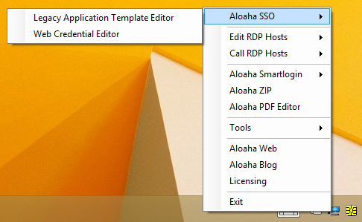
Picture 2: Aloaha Systray

Aloaha SSO Template and Data Editor

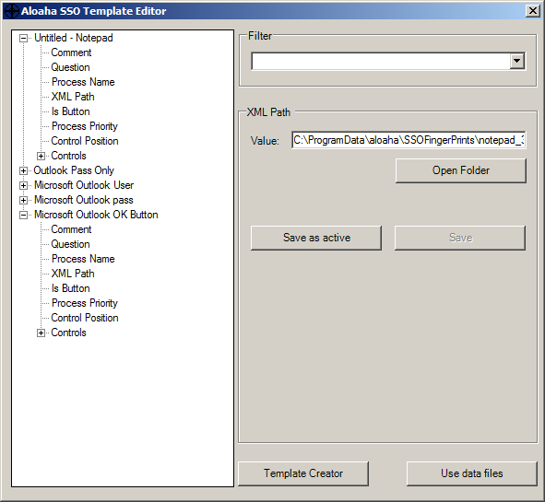
Node Deletion
Picture 3
When you right click on a selected node a menu will pop-up. There you click “Delete Node”.
Please note that per default ONLY nodes owned by the current user can be deleted. You can always click on “XML Path” -> “Open Folder” to open the folder with the XML file and delete it manually.
To allow the deletion of all nodes please set
HKLM\...\Aloaha\SSO\AllowNodeDeletion or
HKCU\...\Aloaha\SSO\AllowNodeDeletion to 1.

Buttons
Once everything has been configured it might be better to disallow the user to edit the templates all together. To do so please set
HKLM\SOFTWARE\<Wow6432Node>\Aloaha\SSO\DisableTemplates or HKCU\SOFTWARE\Aloaha\SSO\DisableTemplates to 1

Template Creator
If you press the button “Template Creator” a new dialog will open. From that dialog you can drag a cross to any windows control to capture it.
You can hide that button with: HKLM\ SOFTWARE \<Wow6432Node>\Aloaha\SSO\DisableTemplateCreator

Use data files
If you see this button the left tree view shows only inactive templates. Pressing the button switches to active data files.

Save as active
Templates are obviously not active. To activate a temple you need to save it as active. The tree view will automatically switch to the active data files.

Use template files
If you see this button the left tree view shows only active data files. Pressing the button switches to the inactive template view.

Save as template
Sometimes it might be necessary to save an active file back into the template folder. Please note that this can be dangerous. For example it could be possible that a user writes his active data file incl. credentials back as a template. For that reason you should consider to write protect the template folder for ordinary user OR to hide the button with: HKLM\SOFTWARE\<Wow6432Node>\Aloaha\SSO\DisableSaveAsTemplate.

Save
Pressing this button saves the current data set or template back to disk.
In case you are editing the data files please NOTE that if HKLM\SOFTWARE\<Wow6432Node>\Aloaha\SSO\SaveUserBased or
HKCU\Software\Aloaha\SSO\SaveUserBased is set to 1 (default) Aloaha will save the data to the path configured in: HKCU\Software\Aloaha\SSO\SSODataPath_alt

Aloaha Template Creator

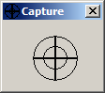
To use the Aloaha Template Creator just click with the left mouse button on the grabber cross and keep it pressed. You see that you mouse cursor changes. Now move the cross to the form field to be captured while you keep the left mouse button pressed. As soon you release the mouse button Aloaha will capture the dialog control under the cross.
Picture 4
When you close the capture window the Aloaha Template Editor will refresh and you see the captured component there.

Settings

Registry
Aloaha registry settings can be found in HKLM\SOFTWARE\<Wow6432Node>\Aloaha and HKCU\SOFTWARE\Aloaha

SysTray
In HKLM\SOFTWARE\<Wow6432Node>\Aloaha\Systray you can define which sub menus of the system tray are being displayed. You can activate a sub menu with setting an entry to 1 or hide an entry with setting an entry to 0.
You can configure the settings also per user based in HKCU\SOFTWARE\Aloaha\Systray
Please note that after changing a setting you need to re-start the RDP Launcher.
Example:
[HKEY_LOCAL_MACHINE\SOFTWARE\Wow6432Node\Aloaha\SysTray]
"aloahasso"="1"
"legacysso"="1"
"websso"="1"
"editrdp"="1"
"rdplist"="1"
"callrdp"="1"
"smartlogin"="1"
"pkcs11"="1"
"usb"="1"
"zip"="1"
"crypter"="1"
"saver"="1"
"signator"="1"
"editor"="1"
"tools"="1"
"adobe"="1"
"ie"="1"
"firefox"="1"
"chrome"="1"
"rdp"="1"
"cmd"="1"
"aloahaweb"="1"
"exitvisible"="1"
"trayvisible"="1"

http://www.aloaha.com/smartcard-software-en/aloaha-credential-provider.php Documentation PDF: http://www.aloaha.com/handbuecher/AloahaSmartlogin_en.pdf Documentation DOCX: http://www.aloaha.com/handbuecher/AloahaSmartlogin_en.docx
http://www.aloaha.com/smartcard-software-en/aloaha-credential-provider.php Documentation PDF: http://www.aloaha.com/handbuecher/AloahaSmartlogin_en.pdf Documentation DOCX: http://www.aloaha.com/handbuecher/AloahaSmartlogin_en.docx
Should that option not be available it was disabled in: HKLM\SOFTWARE\<Wow6432Node>\Aloaha\SysTray\aloahasso
In case the button does not show it was disabled in: HKLM\ SOFTWARE \<Wow6432Node>\Aloaha\SSO\DisableTemplateCreator
Defined in: HKLM\SOFTWARE\<Wow6432Node>\Aloaha\SSO\ConfigPath

