Aloaha Smartlogin

Aloaha Smartlogin allows you to logon to your windows machine with a Smart Card, PKCS #11 Token or USB Memory Stick.

Aloaha even supports plain and simple cards such as MIFARE, I2C or Credit Cards.

Authentication is not limited to the workstation logon but it supports also Remote Desktop, Shares, Hyper-V Sessions, etc.

Domain- and local logons are supported.

Contents

Features 3

Requirements 3

Installation 3

Logon Types 4

Smart Card with any certificate loaded 5

Automatic updating of Softtoken 7

Sharing of Softtoken via Network Share 7

Sharing of Softtoken via Active Directory 8

MIFARE and Keycard 9

UserPass.ini Settings 9

PKCS #11 Token 10

Plain USB Memory Stick 11

UserPass.ini Settings 12

Hide Username Field 12

Aloaha Credential Provider Filter 12

Card Removal Action 13

ForceCRLChecks 13

Emergency Logon 13

Registry Settings 13

Changing of Tile Image 13

Checking of Certificate Revocation Lists 14

Enable/Disable CRL checking 14

CRL checking parameter 14

Windows XP/2003 and GINA (Not supported anymore) 14

SSO for legacy applications 15

Single Sign-On for Web Applications 15

Other useful applications 16

AloahaZIP 16

Create digital certificates 16

Aloaha Crypt Disk 16

**An updated version is always available at:**<http://www.aloaha.com/handbuecher/AloahaSmartlogin_en.docx> <http://www.aloaha.com/handbuecher/AloahaSmartlogin_en.pdf>

**The German version can be found at:**<http://www.aloaha.com/handbuecher/AloahaSmartlogin_de.docx> <http://www.aloaha.com/handbuecher/AloahaSmartlogin_de.pdf>

**Aloaha Smartlogin Homepage:**<http://www.aloaha.com/smart-card-applications/aloaha-smart-login/>

# Features

* Supports full Kerberos authentication (Active Directory required)
* Smart Card Logon even WITHOUT Active Directory possible.
* **No special requirements for the Logon Certificate (KeyCard).**
* Cardlogon even without certificates possible.
* Besides Smart Cards, Aloaha also supports other login tokens such as USB Memory Sticks, MIFARE, Proximity Cards, Memory Cards and PKCS #11[1] Tokens.
* Logon to network shares, remote desktop sessions, Hyper-V Consoles, etc. are also supported.
* Network Level Authentication (NLA) and Credential Security Support Provider (CredSSP) supported.
* Smart Card Logon also for legacy applications (SSO)
* MSI based installer available.

# Requirements

* Windows XP (Logon via GINA – works but with the end of XP not supported anymore)
* Any other Windows from Vista onwards and incl. Windows 8/8.1/10. Both 32 and 64 Bit.
* .NET 3.5 Framework installed
* Active Directory supported but **NOT REQUIRED**
* Optional installed Middleware[2] for Smart Card(s)

# Installation

To install Aloaha you need to start the installer from <http://www.aloaha.com/download/smartlogin.zip>

Please contact [info@aloaha.com](mailto:info@aloaha.com) in case you need the msi installer.

In case you do not own a valid license key please request an evaluation key from [info@aloaha.com](mailto:info@aloaha.com).

**If you are planning to use certificate you need to make sure that the driver/middleware for your smart card is installed. If you do not have any driver/middleware for your smart card OR you are using the Aloaha Card, you can use the Aloaha Cardconnector as your middleware. It currently supports more than 45 different smart cards. Aloaha Cardconnector can be installed from:** [**http://www.aloaha.com/download/cardconnector.zip**](http://www.aloaha.com/download/cardconnector.zip)

# Logon Types

The following logon tokens are supported:

1. Smart Card with any certificate loaded.  
   This is the most common used configuration since it does NOT require the certificate issued by a Domain Certification Authority. Active Directory is supported but not required.  
   <http://www.win-logon.com/smartcard-based-windows-logon-with-any-certificate/>
2. PKCS #11 Token  
   <http://www.win-logon.com/pkcs-11-logon/>
3. Plain USB Memory Stick  
   <http://www.win-logon.com/windows-logon-with-plain-usb-memory-stick/>
4. Kerberos
5. MIFARE/Desfire/KeyCard  
   You can save your credentials encrypted on the MIFARE card.  
   <http://www.win-logon.com/logon-via-keycards-such-as-nfcmifaredesfire/>

## Smart Card with any certificate loaded

If you use a smart card, you need to link the Chip card Certificate with the credentials. To do so please call “Encrypt Credentials” from the Windows Start Menu OR “Card Credentials” from the Aloaha System Tray Menu. The following dialog will open:

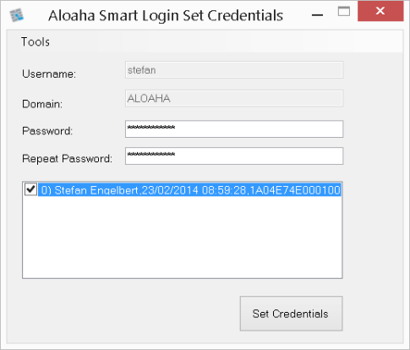

You need to type in your windows password, choose the smart card to be used and click “Set Credentials”.

A Softtoken will be created and saved to <Installdir>\CredentialStore. That Token contains some settings, the public part of the card certificate and a smart card encrypted secret.

**ONLY the private key of the chip card is able to de-crypt this secret!**

Now you are already able to logon with your card to your windows system.

In some cases it might be required that you need to assign a smart card to a different user than suggested. In that case please start **SmartLogin_SetCredentials.exe** with the parameter **/e** from the Aloaha installation folder. The tool will allow you then to edit all fields as shown below:

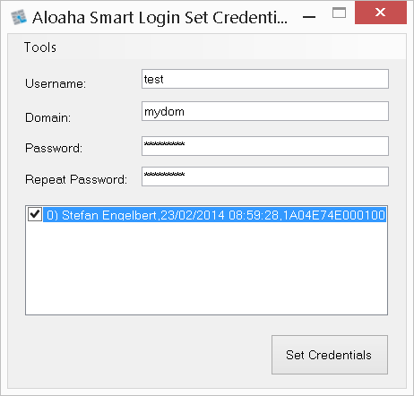

Alternatively, you can use the tool **SetCredentials.exe** from the installation folder. That tool also allows you to verify the smart card assignment(s):

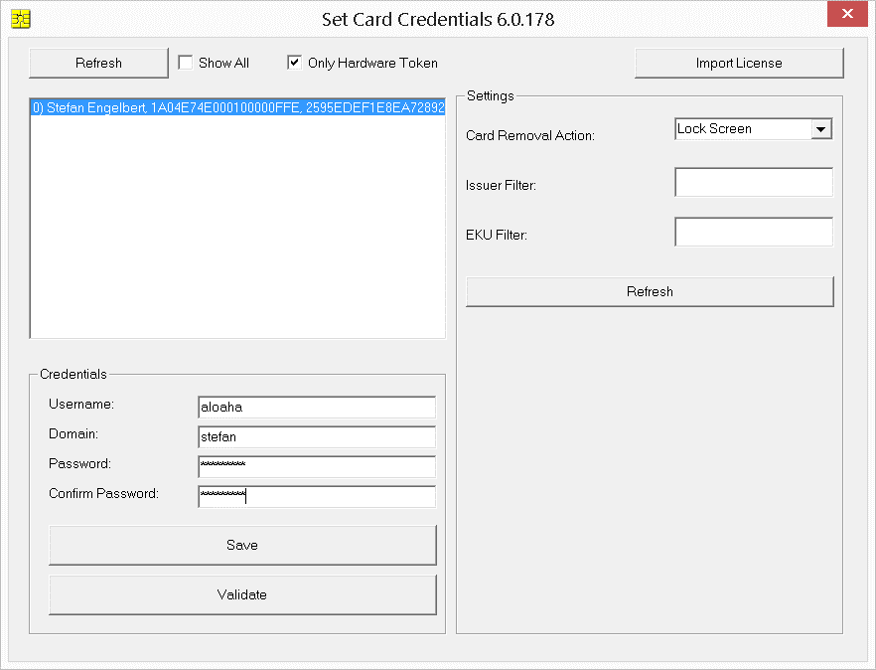

### Automatic updating of Softtoken

The Softtoken Files need to be updated as soon the assigned user changes the password. With the password hook that can be carried out fully automatic.

The password hook needs to be activated on the machine were the password is physically stored. In a domain that is the domain controller. Local Users are stored always on the local machine.

To install and activate the hook please make sure that Smartlogin is installed. You will find the tool **PasswdHK.exe in <InstallDir>\PasswdHK.exe**

Call the tool with right click -> **“Run as Administrator”.** Choose the tab “Activate Password Hook” as shown below:

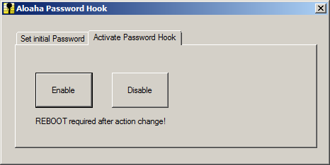

Now please press “Enable” and reboot the machine to activate the hook. Whenever a user now changes the password the Softtoken will automatically updated.

### Sharing of Softtoken via Network Share

It is possible to change the location of the Softtoken. Per default it is <Installdir>\CredentialStore or for the KeyCards it is <Installdir>\SerialStore.

You can change that location in the registry in HKLM\SOFTWARE\<Wow6432Node>\Aloaha\CSP\CredentialStore  
and  
HKLM\SOFTWARE\<Wow6432Node>\Aloaha\CSP\ SerialStore  
and point it to a network share.

But please keep in mind that the logon process is running under local system credentials and thus the share needs to give local system the required permissions.

Better it is to copy network based SoftToken from a share to the local folder.

For the CredentialStore please configure the share in: HKLM\SOFTWARE\<Wow6432Node>\Aloaha\CSP\ForcedCredentialStore  
and for the KeyCards:   
HKLM\SOFTWARE\<Wow6432Node>\Aloaha\CSP\SerialStoreMaster

### Sharing of Softtoken via Active Directory

In case your machines are part of an Active Directory Domain it is suggested to roam the token via AD.

Aloaha is using a dedicated Active Directory Application Partition to store its data. To create the partition please follow the steps below:

1. Make sure you are logged on with a user with **Schema-Admin** rights
2. Create the value **ForceCreate** in **HKLM\SOFTWARE\<Wow6432Node>\Aloaha\AD** and assign the value **1**.
3. Download and run **AloahaADSI** from:   
   <http://23.102.21.128:8080/f/295da15224/>
4. Choose the **“Settings”** tab and fill in your Schema-Admin Username and Password and click “Save”. The Password fields will show empty after the **save**.  
   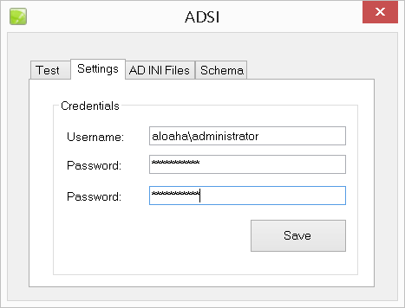
5. Open the **“Schema”** Tab and press “Create Schema”. You should see the output as in the screenshot below if everything was created properly.  
    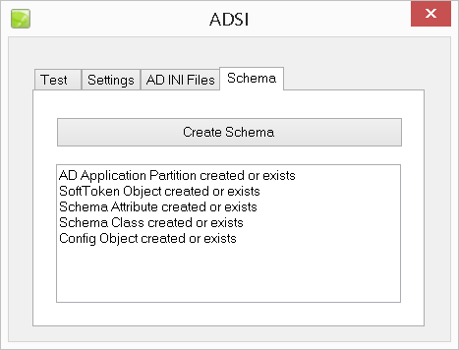
6. Quit the tool and delete **HKLM\SOFTWARE\<Wow6432Node>\Aloaha\AD\ForceCreate** to hide the Schema Tab.

You created now the required Application Partition to share your Softtoken across the domain.

Now you need to enable sharing on EVERY client machine with setting the value **enabled** to **1** in **HKLM\SOFTWARE\<Wow6432Node>\Aloaha\AD** (please create if not exist)

## MIFARE and Keycard

In MIFARE and Keycard we support all tokens which are not falling into one of the other categories. For example MIFARE Classic and Desfire, Zeitkontrol 3.14[3] Cards, Smartcards without certificate and Credit Cards.

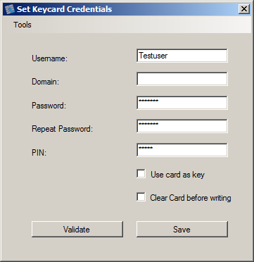Please fill in your Username, optional Domain and obviously your user password.  
  
For the PIN Field you need to invent your own PIN.  
**(It is NOT the PIN of the token itself!)**

That PIN will be part of the secret to be used to encrypt your credentials.

**Please check “Use card as key” unless instructed otherwise.**

### UserPass.ini Settings

To be able to use Mifare or Keycards you might need to activate some options manually in the userpass.ini. You find that file in the installation folder.

[Generic]  
AllowMIFARE=1  
AllowVisa=1  
AllowATR=0  
ForceMonitorKeyCards=1  
AllowPayFlex=0  
AllowPGP=0

In any case you must make sure that **AllowMIFARE** is set to 1. **That is also valid for non-MIFARE Keycards.**

**AllowVisa** needs only be set to 1 if you are planning to use plain Credit Cards as logon token.

**AllowPayFlex** needs only be set to 1 if you are planning to use PayFlex Cards as logon token.

**AllowPGP** needs only be set to 1 if you are planning to use PGP Cards as logon token.

Please set **AllowATR** only to 1 if you are planning to use cards which embed their unique ID in the ATR. For example HID H10301 Proximity Token.

If you set **ForceMonitorKeyCards** to 1 you improve the card removal detection.

## PKCS #11 Token

If you opt to use a PKCS #11 Token to logon to your machine, your credentials will be saved encrypted on the token itself. It is essential that you make sure that the PKCS #11 Library of your token is installed!

To save your credentials on your token please start “PKCS #11 Credentials” from the Windows start menu or Aloaha System tray.

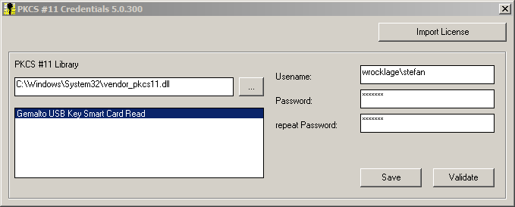

1. Choose your vendors PKCS #11 Library
2. Now your token should be listed. Please choose the token to be used.
3. Enter <domain>\User and Password.
4. Press “Save” to save the encrypted credentials to your token. Click “Validate” to simulate a logon.

## Plain USB Memory Stick

It is also possible to use a plain USB Memory Stick as a logon token. Your credentials will be saved encrypted on the portable memory.

Please note that USB Memory Sticks are LESS secure than real smart cards since they do not use a dedicated crypto processor!

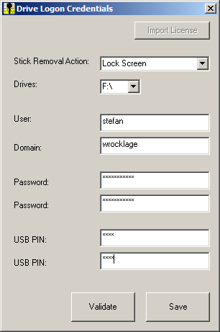

You need to supply the USB drive letter, your username, optional your domain and the windows password. It is also essential that you define a USB PIN. That USB PIN will be later on your logon PIN. The PIN will also form part of the credential encryption key.

UserPass.ini Settings

## Hide Username Field

The Username field of the logon tile can be left empty. Aloaha will then try to guess the right username based on the certificate of the card. You can also disable and hide the username field.

**<Installdir>UserPass.ini**

|  |  |
| --- | --- |
| [Generic] DisableUserName=0 EnableUserName=1 | [Generic] DisableUserName=1 EnableUserName=0 |

## Aloaha Credential Provider Filter

It is possible to hide any Logon Tile via the Aloaha Credential Provider Filter:

In some cases Credential Providers should be hidden from the Logon User Interface BUT still usable from within the session. For example someone might not want to see the Username/Password Tile during logon but obviously still requires it when mounting a network drive or connecting via RDP to another machine. In that case you cannot hide/disable the providers via windows group policy but a Credential Provider Filter is required.

Aloaha Smartlogin comes with an integrated Credential Provider Filter to be able to hide Tiles from the Windows Logon Interface WITHOUT removing its functionality inside the session.

To activate the Aloaha Credential Provider Filter you need to open the file **UserPass.ini** in the installation folder. In the section **CredentialProviders** you can configure different filter for different provider. To enable a filter please set it to 1. Set all the keys as shown below in order to disable ALL non-Aloaha CredentialProviders:

[CredentialProviders]

25CBB996-92ED-457e-B28C-4774084BD562=1  
3dd6bec0-8193-4ffe-ae25-e08e39ea4063=1  
503739d0-4c5e-4cfd-b3ba-d881334f0df2=1  
6f45dc1e-5384-457a-bc13-2cd81b0d28ed=1  
8bf9a910-a8ff-457f-999f-a5ca10b4a885=1  
94596c7e-3744-41ce-893e-bbf09122f76a=1  
AC3AC249-E820-4343-A65B-377AC634DC09=1  
e74e57b0-6c6d-44d5-9cda-fb2df5ed7435=1  
F8A0B131-5F68-486c-8040-7E8FC3C85BB6=1

## Card Removal Action

Per default Aloaha reads the Machines or Domains Card Removal policy. It can be fine-tuned and overwritten with:

[AutoLock]  
PolicyAction=1  
RemoveActionM=1

Furthermore you need to set HKLM\Software\Aloaha\CSP\RemoveAction=1  
1 = Lock Screen, 2 = Lock Off, 3 = Reboot

## ForceCRLChecks

[Generic]  
ForceCRLChecks=1

This if this key is set to 1 it enforces CRL Checking. If this key is set to 1 it CANNOT be deactivated with any other CRL setting.

## Emergency Logon

[Generic]  
AllowUP=1

If AllowUP is activated (default) the user can logon to the machine if he knows the valid user password. He has to add up: for username/password to his username and enter the password instead of the PIN.

For example instead of entering JohnDoe into the Username field you would enter up:JohnDoe

Instead of the PIN 0815 you would enter JohnDoe’s password LetMeIn

**If this emergency logon is NOT required please deactivate it!**

# Registry Settings

## Changing of Tile Image

It is possible to customize the logon tile image. Just create a key called **tileImage** in HKLM\Software\Aloaha\CP and point it to a BMP Image.

**It is suggested that it has a resolution of 480x480x32.**

## Checking of Certificate Revocation Lists

If you have a fresh install of Aloaha Smart Login it will make only very basic checks on the certificate used. Revocation lists will NOT be used.

There are several reasons why revocation checking is disabled by default:

1. When evaluating Aloaha customer usually use test certificates without any valid CA behind. Checks would fail in that case and the customer might not be able to log on by smart card.
2. In case a user reports his smart card as lost the admin could just delete the softtoken to block the lost smart card. The same effect would have been a change of the user’s password. That would lock out immediately the lost smart card but would still allow the user to logon with his new smart card and certificate.

The second point shows that revocation lists are just an extra layer of security but they are not really required. Even without revocation lists cards can be blocked.

### Enable/Disable CRL checking

With the key HKLM\SOFTWARE\<Wow6432Node>\Aloaha\CSP\CertificateAlwaysValid the user can enable or disable the CRL checking. Default is disabled.

### CRL checking parameter

**Only certificates chaining up to the root are valid:**HKLM\<Wow6432Node>\Software\Aloaha\CSP\EnforceChain

HKLM\<Wow6432Node>\Software\Aloaha\CSP\ ForceCRLChecks  
See also in Chapter: **ForceCRLChecks**

**Define CRL Type:**  
HKLM\<Wow6432Node>\Software\Aloaha\CSP\ForceCRL  
HKLM\<Wow6432Node>\Software\Aloaha\CSP\offCRL  
HKLM\<Wow6432Node>\Software\Aloaha\CSP\onlCRL  
HKLM\<Wow6432Node>\Software\Aloaha\CSP\ForceOCSP

**Consider unknown status as valid:**  
HKLM\<Wow6432Node>\Software\Aloaha\CSP\UnknownCertStatusIsValid

**Accept expired certificates:**  
HKLM\<Wow6432Node>\Software\Aloaha\CSP\IgnoreCertTime

# Windows XP/2003 and GINA (Not supported anymore)

On Windows XP/2003 Aloaha will install a GINA dll instead of the credential provider. In some cases it might be required to deactivate or remove the GINA. In that case you need to remove GinaDLL from HKLM\SOFTWARE\Microsoft\Windows\CurrentVersion.



# SSO for legacy applications

Please read the following documentation:

PDF: <http://www.aloaha.com/handbuecher/l_sso.pdf>

DOCX: <http://www.aloaha.com/handbuecher/l_sso.docx>

# Single Sign-On for Web Applications

**PDF:** <http://www.aloaha.com/handbuecher/HTML_SSO.pdf>

**DOCX:** <http://www.aloaha.com/handbuecher/HTML_SSO.docx>

# Other useful applications

Aloaha offers a couple of small and portable applications for Aloaha user.

## AloahaZIP

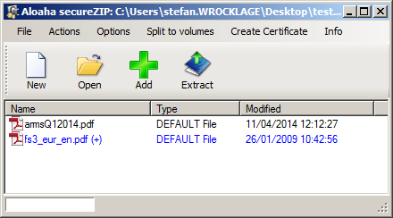

With AloahaZIP you can certificate encrypt your ZIP documents:

[http://www.aloaha.com/download/aloahazip.zip](http://www.aloaha.com/donwload/aloahazip.zip)

## Create digital certificates

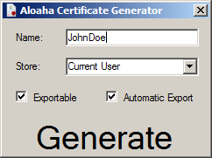To create quickly exportable or non-exportable certificates please use the following tool:   
  
[http://www.aloaha.com/download/AloahaCertificateCreator.zip](http://www.aloaha.com/donwload/AloahaCertificateCreator.zip)

## Aloaha Crypt Disk

With Aloaha Crypt Disk you can create a certificate or smart card encrypted drive container:

[http://www.aloaha.com/download/AloahaCrypt%20Setup1.3b.zip](http://www.aloaha.com/donwload/AloahaCrypt%20Setup1.3b.zip)

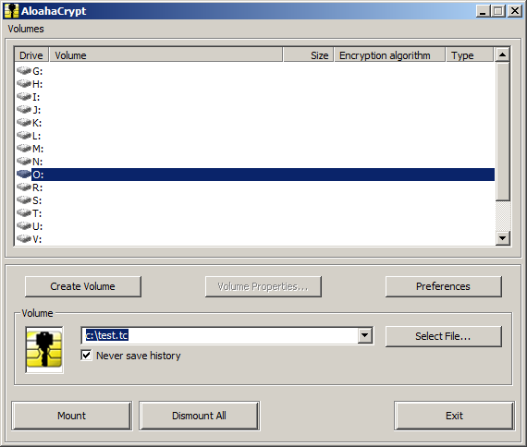 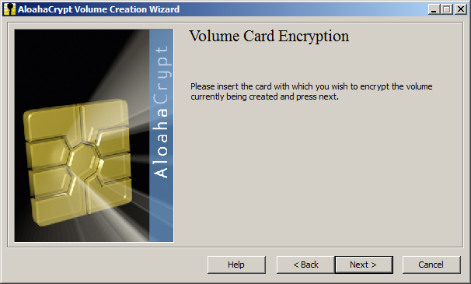

1. Please make sure you install the PKCS #11 Library of your token.
2. The Aloaha Cardconnector Middleware supports more than 45 different Smart Cards. In case you do not have a middleware for your smart card or you are using the Aloaha Card please install the Aloaha Cardconnector from <http://www.aloaha.com/download/cardconnector.zip>
3. With Aloaha Firmware